VISVESVARAYA TECHNOLOGICAL UNIVERSITY
BELGAUM-590014

A DBMS Mini-Project Report On

“Railway Management System”
A Mini Project report submitted in partial fulfillment of the requirements for the award of the degree of Bachelor of Engineering in Computer Science and Technology of Visvesvaraya Technological University, Belgaum
Submitted by:

Pavan Madival (1DT20CS094) Rajesh Kumar (1DT20CS106) Sahil Sharma (1DT20CS116)

Under the Guidance of:
Prof Keerthana Shankar (Asst. Prof. Dept of CSE)



DAYANANDA SAGAR ACADEMY OF TECHNOLOGY & MANAGEMENT
(Affiliated to Visvesvaraya Technological University, Belagavi and Approved by AICTE, New Delhi)
Opp. Art of Living, Udayapura, Kanakapura Road, Bangalore- 560082 (Accredited by NBA and NAAC (A+))


DAYANADA SAGAR ACADEMY OF TECHNOLOGYAND MANAGEMENT,
(Affiliated to Visvesvaraya Technological University, Belagavi and Approved by AICTE, New Delhi)
Opp. Art of Living, Udayapura, Kanakapura Road, Bangalore-560 082 (Accredited by NBA, New Delhi, NAAC (A+))
DEPARTMENT OF COMPUTER SCIENCE & ENGINEERING

CERTIFICATE

This is to certify that the Mini-Project on Database Management System (DBMS) entitled “Railway Management System” has been successfully carried out by PAVAN MADIVAL (1DT20CS094), RAJESH KUMAR(1DT20CS106) and SAHIL
SHARMA(1DT20CS116) a bonafide students of Dayananda Sagar academy of technology and management in partial fulfillment of the requirements for the award of degree in Bachelor of Engineering in Computer Science and Engineering of Visvesvaraya Technological University, Belgaum during academic year 2022-23. It is certified that all corrections/suggestions indicated for Internal Assessment have been incorporated in the report deposited in the departmental library. The mini project report has been approved as it satisfies the academicrequirements in respect of project work for the said degree.

Internal Guide:
Mrs. Keertana Shankar Assistant Professor Dept. of CSE

HOD:
Dr Kavitha C HOD, Dept. of CSE

Examiner 1 Examiner 2

ACKNOWLEDGEMENT

It gives us immense pleasure to present before you our project titled “RAILWAY MANAGEMENT SYSTEM”. The joy and satisfaction that accompany the successful completion of any task would be incomplete without the mention of those who made it possible. We are glad to express our gratitude towards our prestigious institution DAYANANDA SAGAR ACADEMY OF TECHNOLOGY AND MANAGEMENT for
providing us with utmost knowledge, encouragement and the maximum facilities in undertaking this project.

We wish to express a sincere thanks to our respected principal Dr. M Ravishankar for all their support.
We express our deepest gratitude and special thanks to Dr. Kavitha C, H.O.D, Dept of Computer Science Engineering, for all her guidance and encouragement.
We sincerely acknowledge the guidance and constant encouragement of our mini-project guide Assistant professor Prof. Keerthana Shankar, Asst. Professor, Dept of CSE.

PAVAN MADIVAL (1DT20CS094) RAJESH KUMAR (1DT20CS106) SAHIL SHARMA (1DT20CS116)

TABLE OF CONTENTS

Chapter | Chapter Name | Page

1 | INTRODUCTION | 1
1.1 | Brief Description | 1
1.2 | Objectives | 1
1.3 | Scope of the project | 1
1.4 | Analysis | 2

2 | REQUIREMENTS | 3
2.1 | Functional & Non-Functional | 3
2.2 | Hardware Requirements | 3
2.3 | Software Requirements | 4

3 | SYSTEM DESIGN | 5
3.1 | Abstract | 5
3.2 | E-R Diagram | 6
3.3 | Schema Diagram | 7
3.4 | Table Description | 8

4 | IMPLEMENTATION | 12
4.1.1 | Login Module | 12
4.1.2 | User operation Module | 12
4.1.2.1 | Creation Module | 12
4.1.2.2 | Authentication Module | 13
4.1.2.3 | Management Module | 14
4.1.2.4 | Analytics Module | 14
4.2 | Database Connection and  source code | 15-26

5 | TESTING | 27
5.1 | Testing Table | 27-28

6 | RESULT ANALYSIS AND SCREENSHOTS | 29

7 | CONCLUSION AND MERITS | 33
7.1 | Conclusion | 33
7.2 | Merits | 33
7.3 | Future Enhancements | 33

BIBLIOGRAPHY | 34
Website Reference | 34
PERSONAL DETAILS | 35

LIST OF FIGURES

SI | FIGURE# | TOPIC | PAGE#
1 | 3.2 | ER DIAGRAM | 6
2 | 3.3 | Relational Schema | 7
3 | 4.2.1 | DataBase Connection | 15
4 | 4.2.2 | Insert Query | 15
5 | 4.2.3 | Select Query | 16
6 | 4.2.4 | Update Query | 16
7 | 6.1 | Home Page | 29
8 | 6.2 | Sign Up Page | 29
9 | 6.3 | Admin Login Page | 30
10 | 6.4 | Admin Find Train Page | 31
11 | 6.5 | Admin Booking Reservation Page | 31
12 | 6.6 | Admin Booking History | 32

LIST OF TABLES

SI | FIGURE# | Name | PAGE#
1 | Table 3.4.1 | Structure Of User Info | 8
2 | Table 3.4.2 | Structure Of Train List | 8
3 | Table 3.4.3 | Structure Of Seats | 9
4 | Table 3.4.4 | Structure Of Interlist | 9
5 | Table 3.4.5 | Structure Of Booking | 10
6 | Table 3.4.6 | Trigger In Train List | 11

1
CHAPTER 1

INTRODUCTION

BRIEF DESCRIPTION
- The mini-project entitled “Railway reservation management system“ is developed as a part of the fifth semester DBMS laboratory, for the partial fulfilment of the requirement for the BE(Computer Science) course.
- Our website has various kinds of information that helps regarding booking of tickets via railways .
- Users will be able to search the train availability ,the exact fare ,the arrival and departure time of the train and they can also book the ticket by using the debit ,credit or master card and after booking the ticket if the user want to cancel it then they can easily do it also.

OBJECTIVES

The objective of the online railway reservation management system

Project is to design software to fully automate the process of issuing a railway ticket. That is:-
- To create a database of the trains

- To search the trains it’s arrival and departure time, distance between source and destination.
- To check the availability of the ticket.

- To calculate fare.
- To book the ticket.

- To cancel the ticket if necessary

SCOPE OF THE PROJECT
    - Railway passengers frequently need to know about their ticket reservation status, ticket availability on a particular train or for a place, train arrival or departure details, special trains etc... Customer information centers at the railway stations are unable to serve such
queries at peak periods.

    - The number of the reservation counters available to the passengers and customers are very less.
2
    - On most of the reservation systems there are long queues, so it takes a long time for any individual to book the ticket. As now there are no call centers facilities available to solve the queries of the passengers.
    - The online railway ticket reservation system aims to develop a web application which aims at providing trains details, trains availability, as well as the facility to book ticket in online for customers.
    - So, we thought of developing a web based application which would provide the users all these facilities from his terminal only as well as help them in booking their tickets. The Application was to be divided into two parts namely the user part , and the administrator part. And each of these has their corresponding features. We decided to give the name of the
    - website “RAILWAY RESERVATION MANAGEMENT SYSTEM”. The online railway
    - ticket reservation system is developed using ASP.NET with C# as the backend in the
.NET Framework.

ANALYSIS
Railway reservation management system is an online ticket booking website, which is capable of booking ticket and search the train availability . This website is mainly created to fulfil the following requirements, it comprises of the following properties:-
    - A central database that will store all information.
    - An online website that will provide real- time information about the availability of tickets their prices .
    - Every registered user is able to view his booking id that has been made in his/her name.
    - Every registered user can change his password any time he wants to change.

3
CHAPTER 2

REQUIREMENTS

The requirements can be broken down into 3major categories namely functional and non functional,hardware and software requirements. The former specifies the minimal hardware facilities expected in asystem in which the project has to be run. The latter specifies the essential software neededto build and run the project.

FUNCTIONAL AND NON FUNCTIONAL

The required software is used for ordering food online. The system should satisfy the following requirements:
- Logging into the system
- Signup option

- View Menu Details
- Order Option

- View User Orders

- Logout option

HARDWARE REQUIREMENT

- A desktop or laptop with a proper internet connection
- 2 500GB or 60GB of the hard disk
- 3.4GB 2GB of the RAM
- Windows 7 or 8 or 10 Operating system

4

SOFTWARE REQUIREMENT

Server side
- Programming language: PHP 5.6.31
- Web Server: Apache 2.4.27
- Database: SQL 5.7.19

Client side
- Programming language: JAVASCRIPT, HTML, CS
- OS: windows7/8/10
- MYSQL server

5
CHAPTER 3

SYSTEM DESIGN

ABSTRACT

    - Railway Management System facilitates the passengers to enquiry about the trains available on the basis of source and destination, booking and cancellation of tickets, enquiry about the status of the booked ticket, etc. The aim of case study is to design and develop a data base maintaining records of different trains, train status and passengers
.This project contains introduction to the railways reservation system. It is the computerized system of reserving the seats of train seats in advance. It is mainly used for a long route. Online reservation has made the process for the reservation of seats very much easier than ever before.
    - In our country India, there are number of counters for the reservation of the seats and one can easily make reservations and get tickets. Railway Management System, has described above, can lead to error free, secure, reliable and fast management system. It can assist the user to concentrate on their other activities rather to concentrate on the record keeping. Thus it will help organization it better utilization of resources
.Administrator of the project, with the help of a password, can enter new train record, display all train records, modify train records and delete train records. The record of train includes its number, name, source, destination, and days on which it is available, whereas record of train status includes dates for which tickets can be booked, total number of seats available, and number of seats already booked.

ER DIAGRAM

An entity–relationship model describes inter-related things of interest in a specific domain of knowledge. An ER model is composed of entity types and specifies relationships that can exist between instances of those entity types.

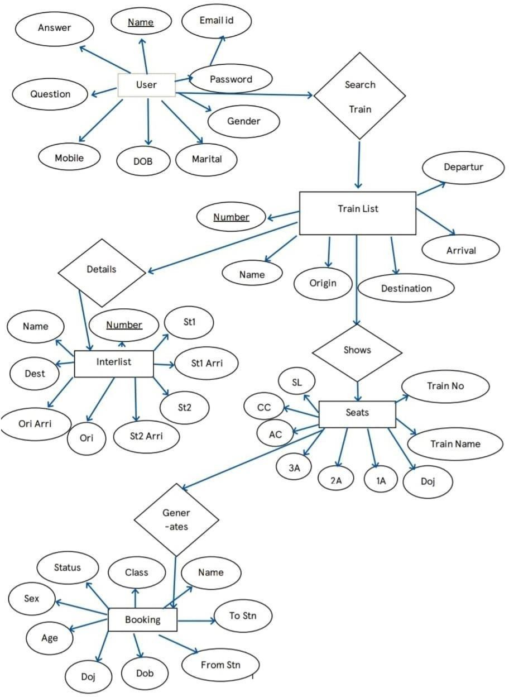
Figure 3.2 E R Diagram

This ER Diagram gives a brief idea about the relations existing between the tables and talks about the primary and the foreign keys being used in this Database.

RELATIONAL SCHEMA DIAGRAM

A database schema can be represented in a visual diagram, which shows the database object and their relationship which represents the logical view of the database and how the relationships among them are represented.

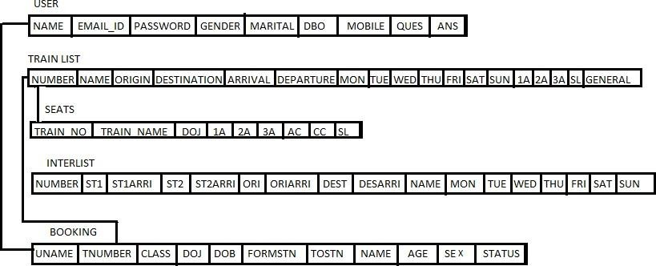

Fig 3.3 Relational Schema for Railway management

TABLE DESCRIPTION

USERINFO
USERINFO table has a attributes f_name ,I_name ,email,password,gender, marital,dob,mobile,ques,ans is used shown in table 2.1
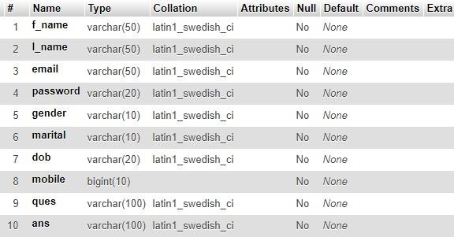

TABLE 3.4.1 STRUCTURE OF USER INFO

TRAIN LIST
TRAIN LIST table has a attributes number,name,origin,destination,arrival,departure, mon,tue,wed,thu,fri,sat,sun,1A,2A,3A,SL,General and number is used as a primary key as shown in table 2.
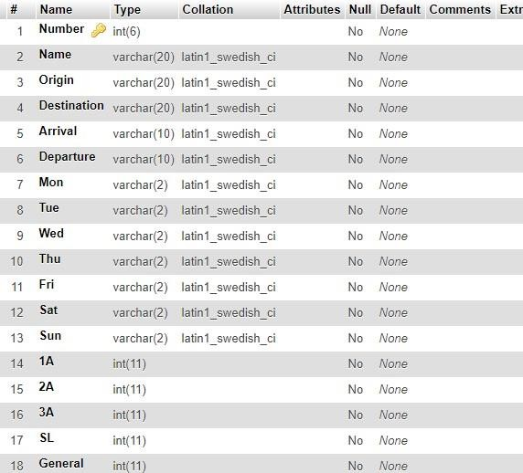

TABLE 3.4.2 STRUCTURE OF TRAIN LIST

SEATS
SEATS table has the attribute train_no,train_name,doj,1A,2A,3A,AC,CC,SL is used shown in the table 2.3

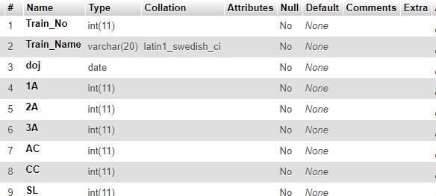
TABLE 3.4.3 STRUCTURE OF SEATS

INTERLIST
INTERLIST table has the attribute number,st1,st1arri,st2,st2arri,st3,st3arri,st4,st4arri, st5,st5arri,ori,oriarri,dest,desarri,name,mon,tue,wed,thu,fri,sat,sun as shown in
Table 2.4

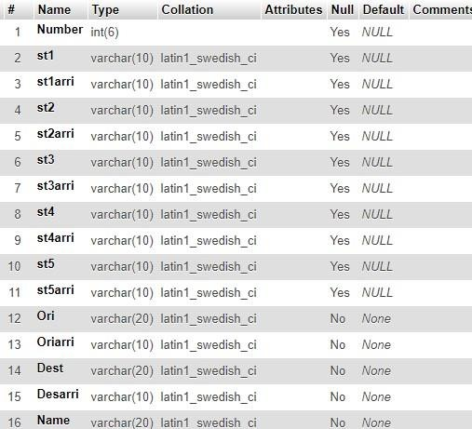

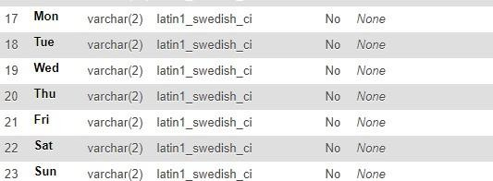

TABLE 3.4.4 STRUCTURE OF INTERLIST

BOOKING
BOOKING table has theattributeuname,Tnumber,class,doj,DOB,fromstn,tostn, name,age,sex,status as shown in table 2.5
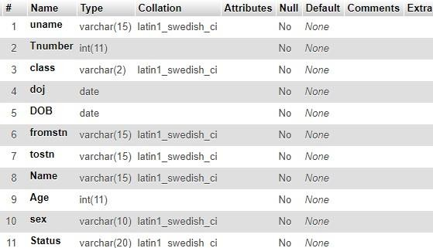

TABLE 3.4.5 STRUCTURE OF BOOKING

TRIGGERS
A trigger is a special type of stored procedure that automatically executes when an event occurs in the database server.

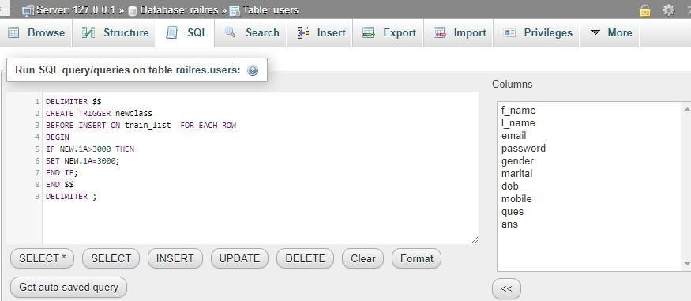

TABLE 3.4.6 Trigger in Train list

CHAPTER 4

IMPLEMENTATION
4.1 MODULES

LOGIN MODULE:

User Login Process takes the User details such as Center name and Password as input for successful login. The output is a status message which shows the user is successfully logged or an error popup is displayed when incorrect credentials are filled in the input fields. Error is also generated when a non-registered user attempts to login.

USER OPERATION MODULE:

The User Identity Management System consists of 4 modules. They are:

      - Creation Module

      - Authentication Module

      - Management Module

      - Analytics Module

Creation Module

This module is used to add the details of new individuals.

        - Details such as the individual’s first name, surname, address, date of birth, gender, phone number and photo are accepted.

        - Other details such as the center at which they were a registered and the date of registration are added as well.
        - A unique ID is given to each individual,

        - If the individual is the first from their family to register then a new family ID is created. Otherwise, the user is associated with the ID of their family.

Authentication Module

This module is used for the purpose of verification.

        - For the users, this provides access to the database after the user inputs their given login IDs. It ensures that there is no unauthorized access.
        - For individuals, during the registration process they are to provide a mail which serves both as a means of communication and also as means for authentication.
        - A mail containing an OTP is sent to the mail ID provided by the user. This must be provided so that the registration process can be completed and term the mail ID of the user to be bona fide.

Management Module

This module is used for the purpose of viewing and managing the data in the database.

        - It provides various functionalities to search the data using various parameters such as uid, family id and phone number.
        - It also provides numerous functions which can be used to sort the data and easily identify the results.
        - Other functions for viewing the database, changing various aspects of the database such as its tables and user levels are also present.

Analytics Module

This module is used for analyzing and evolving the database.

        - It provides methods which produce graphs for various aspects of the database.

        - Detailed reports may be obtained on demand.

        - We can continue expansion and development of the database with the help of this module.

  - DATABASE CONNECTIVITY:

A database connection is a facility in computer science that allows client software to talk to database server software, whether on the same machine or not. A connection is required to send and receive commands.

Steps for establishing connection:

DATABASE CONNECTION
The connect() / mysqli_connect() function opens a new connection to the MySQL server with the following syntax : mysqli_connect(host, username, password, dbname, port, socket)

FIG 4.2.1 DATABASE CONNECTION

INSERT QUERY
This query is used to insert a booking .
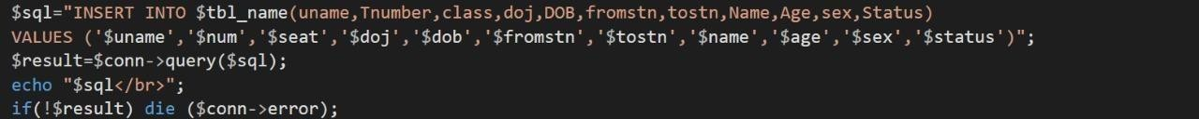

FIG 4.2.2 INSERT QUERY

SELECT QUERY
In this query, all the details are fetched using SELECT* command
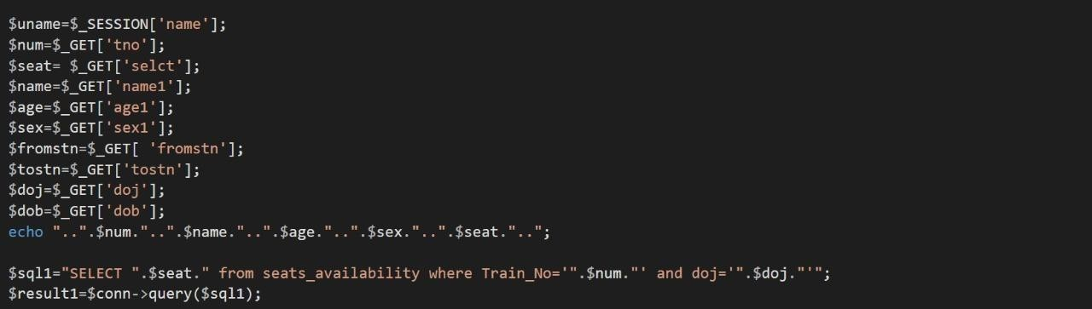
FIG 4.2.3 SELECT QUERY

UPDATE QUERY
Here the update query is called to update the user of an already existing based on its name and category id,address etc respectively.
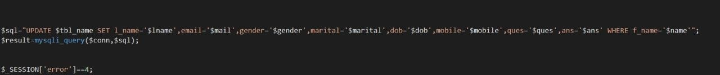

FIG 4.2.4 UPDATE QUERY

createConnection(): method Accepts multiple key value pairs to setup the connection.

Localhost: hostname is usually localhost, which indicates that the database is running on the same server as your application.
Since user name is root there is no password set.

database defines the name of the database with which the connection is to established.

Connect calls the interface for connection taking err as callback value ,which returns err is connection was unsuccessful or else consoles mysql connected

SOURCE CODE:
- Index.php

<?php session_start();
?>

<!DOCTYPE html>
<html>
<head>
<title> Indian Railways </title>
<link rel="shortcut icon" href="images/favicon.png"></link>
<meta charset="utf-8">
<meta name="viewport" content="width=device-width, initial-scale=1.0">
<meta name="description" content="">
<meta name="author" content="">
<link href="css/bootstrap.min.css" rel="stylesheet" ></link>
<link href="css/bootstrap.css" rel="stylesheet" ></link>
<link href="css/Default.css" rel="stylesheet" > </link>
<script type="text/javascript" src="js/jquery.js"></script>
<script>
$(document).ready(function()
{
var x=(($(window).width())-1024)/2;
$('.wrap').css("left",x+"px");
});
</script>

<script type="text/javascript" src="js/bootstrap.min.js"></script>
<script type="text/javascript" src="js/bootstrap.js"></script>
<script type="text/javascript" src="js/man.js"></script>

</head>
<body>

<div class="wrap">
<!-- Header -->
<div class="header">
<div style="float:left;width:150px;">
<img src="images/logo.jpg"/>
</div>
<div>
<div style="float:right; font-size:20px;margin-top:20px;">
<?php if(isset($_SESSION['name']))
{
echo "Welcome,".$_SESSION['name']."&nbsp;&nbsp;&nbsp;<a href=\"logout.php\" class=\"btn btn-info\">Logout</a>";
}
else
{
?>
<a href="login1.php" class="btn btn-info">Login</a>&nbsp;&nbsp;&nbsp;&nbsp;
<a href="signup.php?value=0" class="btn btn-info">Signup</a>
<?php } ?>

</div>
<div id="heading">
<a href="index.php">Indian Railways</a>
</div>
</div>
</div>

<!-- Navigation bar -->
<div class="navbar navbar-inverse">
<div class="navbar-inner">
<div class="container" >
<a class="brand" href="index.php" >HOME</a>
<a class="brand" href="train.php" >FIND TRAIN</a>
<a class="brand" href="reservation.php">RESERVATION</a>
<a class="brand" href="profile.php">PROFILE</a>
<a class="brand" href="display.php">BOOKING HISTORY</a>
</div>

</div>
</div>
<div class="span12 well">
<!-- Photos slider -->
<div id="myCarousel" class="carousel slide" style="width:600px; float:left;margin- bottom:3px;">
<div class="carousel-inner">
<div class="active item"><img src="images/6.jpg" style="width:600px;height:350px;"/></div>
<div class="item"><img src="images/7.jpg" style="width:600px;height:350px;"/> </div>
<div class="item"><img src="images/8.jpg" style="width:600px;height:350px;"/></div>
<div class="item"><img src="images/9.jpg" style="width:600px;height:350px;"/></div>
<div class="item"><img src="images/10.jpg" style="width:600px;height:350px;"/> </div>
<div class="item"><img src="images/11.png"style="width:600px;height:350px;"/></div>

</div>
<a class="carousel-control left" href="#myCarousel" data-slide="prev">&lsaquo;</a>
<a class="carousel-control right" href="#myCarousel" data-slide="next">&rsaquo;</a>
</div>
<!-- News and Alert-->
<div class="news" Style="float:right;">
<marquee behavior="scroll" id="marq" scrollamount=3 direction="up" height="294px" onmouseover="nestop()" onmouseout="nestrt()">
<div>
<p><b>There is no proposal to extend to mail/express and superfast trains the flexi-fares currently applicable only to Rajdhani, Shatabdi and Duronto trains, said Railways Minister Suresh Prabhu.</b></p>
</br>
<p><b>The Railway ministry has posted the rate list on its Twitter account while asking people to lodge a complaint if they are overcharged.</b></p></br>
<p><b>The Comptroller and Auditor General (CAG) has asked the railways to revise passenger fares and curtail concessional passes to recover its operating cost in a phased manner.</b></p></br>
<p><b>Railway issues new catering policy for better food.</b></p></br>
<p><b>Passengers will now be involved in judging cleanliness level of popular trains including Rajdhani, Shatabdi and Duronto as well as major stations across the country.</b><p></br>

</div>

</marquee>
</div>
</div>

<!-- Copyright -->
<footer >
<div style="width:100%;">
<div style="float:left;">
<p class="text-right text-info"> WELCOME</p>
</div>
<div style="float:right;">
<p class="text-right text-info"> ENJOY YOUR JOURNEY </p>
</div>
</div>
</footer> </div>

</body>
</html>
<?php if(isset($_SESSION['error']))
{
session_destroy();
}

?>

Display.php
<?php
session_start();

require('firstimport.php'); if(isset($_SESSION['name'])){}
else{
header("location:login1.php");

}
$tbl_name="booking";

mysqli_select_db($conn,"$db_name") or die("cannot select db");
$name1=$_SESSION['name'];
$sql="SELECT DISTINCT Tnumber,class,doj,DOB,fromstn,tostn,Status FROM $tbl_name WHERE uname='$name1' ORDER BY doj ASC";
$result=mysqli_query($conn,$sql);
$row=mysqli_fetch_array($result);

$tnum=$row['Tnumber'];
$cl=$row['class'];
$result=mysqli_query($conn,"SELECT * FROM train_list WHERE Number='$tnum'");

$row=mysqli_fetch_array($result);
$tname=$row['Name'];
$result=mysqli_query($conn,$sql);

if(isset($_SESSION['name']))
{
//echo "Welcome,".$_SESSION['name']."&nbsp;&nbsp;&nbsp;<a href=\"logout.php\" class=\"btn btn-info\">Logout</a>";
}
else
{
$_SESSION['error']=15;

header("location:login1.php");
}
?>
<!DOCTYPE html>
<html>
<head>
<title> Reservation </title>
<link rel="shortcut icon" href="images/favicon.png"></link>

<meta charset="utf-8">
<meta name="viewport" content="width=device-width, initial-scale=1.0">
<meta name="description" content="">
<meta name="author" content="">
<link href="css/bootstrap.min.css" rel="stylesheet">
</link>
<link href="css/Default.css" rel="stylesheet">
</link>
<script type="text/javascript" src="js/jquery.js"></script>
<script>
$(document).ready(function()
{
var x=(($(window).width())-1024)/2;
$('.wrap').css("left",x+"px");
});

</script>
<script type="text/javascript" src="js/bootstrap.min.js"></script>

<script type="text/javascript" src="js/bootstrap.js"></script>
<script type="text/javascript" src="js/man.js"></script>

</head>
<body>
<div class="wrap">
<div class="header">
<div style="float:left;width:150px;">
<img src="images/logo.jpg"/>
</div>

<div>
<div style="float:right; font-size:20px;margin-top:20px;">
<?php if(isset($_SESSION['name']))
{
echo "Welcome,".$_SESSION['name']."&nbsp;&nbsp;&nbsp;<a href=\"logout.php\" class=\"btn btn-info\">Logout</a>";
}
?>

</div>
<div id="heading">
<a href="index.php">Indian Railways</a>
</div>
</div>
</div>
<!-- Navigation bar -->
<div class="navbar navbar-inverse" >
<div class="navbar-inner">
<div class="container" >
<a class="brand" href="index.php" >HOME</a>
<a class="brand" href="train.php" >FIND TRAIN</a>
<a class="brand" href="reservation.php">RESERVATION</a>
<a class="brand" href="profile.php">PROFILE</a>
<a class="brand" href="display.php">BOOKING HISTORY</a>
</div>
</div>
</div>

<div class="span12 well">
<div align="center" style="border-bottom: 3px solid #ddd;">
<h2>Booked Ticket History </h2>

</div>
<br>
<!--
<div >
<table class="table">

<tr>
<th style="border-top:0px;" > <label>Train No.<label></th>
<td style="border-top:0px;"><label class="text-error"><?php echo $tnum;?></label></td>
<th style="border-top:0px;"><label> Train Name<label> </th>
<td style="border-top:0px;"><label class="text-error"><?php echo $tname;?></label></td>
<th style="border-top:0px;"> <label>Class <label></th>
<td style="border-top:0px;"><label class="text-error"><?php echo $cl;?></label></td>

</tr>
</table>
</div>
-->
<div>

</div>
<div >
<table class="table">
<col width="90">
<col width="90">
<col width="90">
<col width="110">
<col width="90">
<col width="90">
<col width="90">
<col width="90">
<tr>
<th style="width:10px;border-top:0px;">SNo.</th>
<th style="width:100px;border-top:0px;">Train Number</th>
<th style="width:100px;border-top:0px;">Date Of Journey</th>
<th style="width:100px;border-top:0px;">From</th>
<th style="width:100px;border-top:0px;">To</th>
<th style="width:100px;border-top:0px;">Date Of Booking</th>
<th style="width:100px;border-top:0px;">Current Status</th>
</tr>
<?php

$n=1; while($row=mysqli_fetch_array($result)){

if($n%2!=0)
{
?>
<tr class="text-error">
<th style="width:10px;"> <?php echo $n; ?> </th>
<th style="width:100px;"> <?php echo $row['Tnumber']; ?> </th>
<th style="width:100px;"> <?php echo $row['doj']; ?> </th>
<th style="width:100px;"> <?php echo $row['fromstn']; ?> </th>
<th style="width:100px;"> <?php echo $row['tostn']; ?> </th>
<th style="width:100px;"> <?php echo $row['DOB']; ?> </th>
<th style="width:100px;"> <?php echo $row['Status']; ?> </th>
<th style="width:100px;"><a href="ViewFullStatus.php?Tnumber=<?php echo
$row['Tnumber'];?>&doj=<?php echo $row['doj'];?>&fromstn=<?php echo $row['fromstn'];
?>&tostn=<?php echo $row['tostn']; ?>&DOB=<?php echo $row['DOB'];?>">View Full Status </a>
</th>
</tr>
<?php
}
else
{
?>
<tr class="text-info">
<td style="width:10px;"> <?php echo $n; ?> </td>
<th style="width:100px;"> <?php echo $row['Tnumber']; ?> </th>
<th style="width:100px;"> <?php echo $row['doj']; ?> </th>
<th style="width:100px;"> <?php echo $row['fromstn']; ?> </th>
<th style="width:100px;"> <?php echo $row['tostn']; ?> </th>
<th style="width:100px;"> <?php echo $row['DOB']; ?> </th>
<th style="width:100px;"> <?php echo $row['Status']; ?> </th>
<th style="width:100px;"><a href="ViewFullStatus.php?Tnumber=<?php echo
$row['Tnumber'];?>&doj=<?php echo $row['doj'];?>&fromstn=<?php echo $row['fromstn'];
?>&tostn=<?php echo $row['tostn']; ?>&DOB=<?php echo $row['DOB'];?>">View Full Status </a>
</th>

</tr>
<?php
}
$n++;
}

?>

</table>

</div>
</div>

<!-- Copyright -->

</div>
</body>
</html>

CHAPTER 5
TESTING

SOFTWARE TESTING

Software testing is the process of evaluating a software system or application to determine whether it meetsthe specified requirements and works correctly. The goal of testing is to identify any defectsor issues in the software before it is released to customers. It involves the execution of software components using manual and automated tools.

TESTING TABLE

SI | DATA INPUT | EXPECTED OUTPUT | ACTUAL OUTPUT | PASS/ FAIL
1 | Invalid User name and Password | Error: Username and Password Wrong !!! | Error: Username and Password Wrong !!! | PASS
2 | Valid login credentials | Logged in Successful | Logged in Successful | PASS
3 | Insert Invalid phone no | Mobile No. is not valid | Mobile No. is not valid | PASS
4 | Find Trains without login / sign in | Show Trains | Show Trains | PASS
5 | Non existing Email | Email Error | No error | FAIL
6 | Valid Username | User Found | User Found | PASS
7 | In-valid Password | Error : password must be atleast 8 - 32 char long | Error : password must  be atleast 8 - 32 char long | PASS
8 | Insert Non existing Train Name into details | Reference Error | No Error | FAIL
9 | Reservation without Login / sign in | Reference Error : Please Login First.. | Reference Error : Please Login First.. | PASS

Reason for failure:

    - Non existing Email: The project does not include e-mail verifying module in-order to validate the authenticity of the email id.

    - Insert Non existing Train Name into details: The project allows to manually Search Trains by Name, Number, Station . But it does not include verifying invalid inputs.

CHAPTER 6

RESULT ANALYSIS AND SCREENSHOT

HOME PAGE
This is the first window when the application is executed as shown in Fig B.1
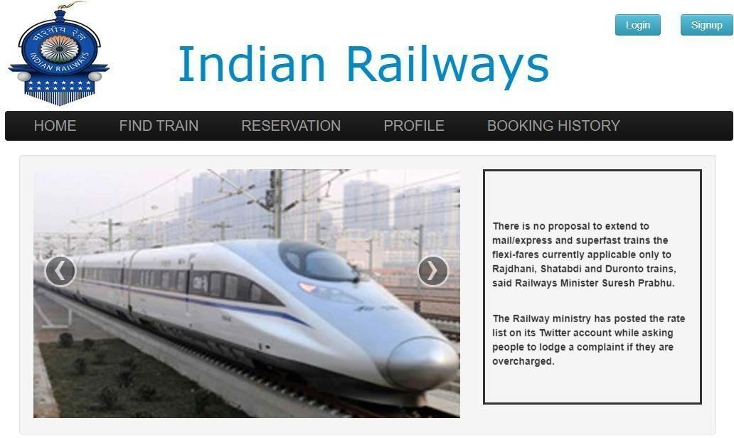
FIG 6.1 HOME PAGE

SIGN UP PAGE
The page allows admin to sign up to database as shown in Fig B.2

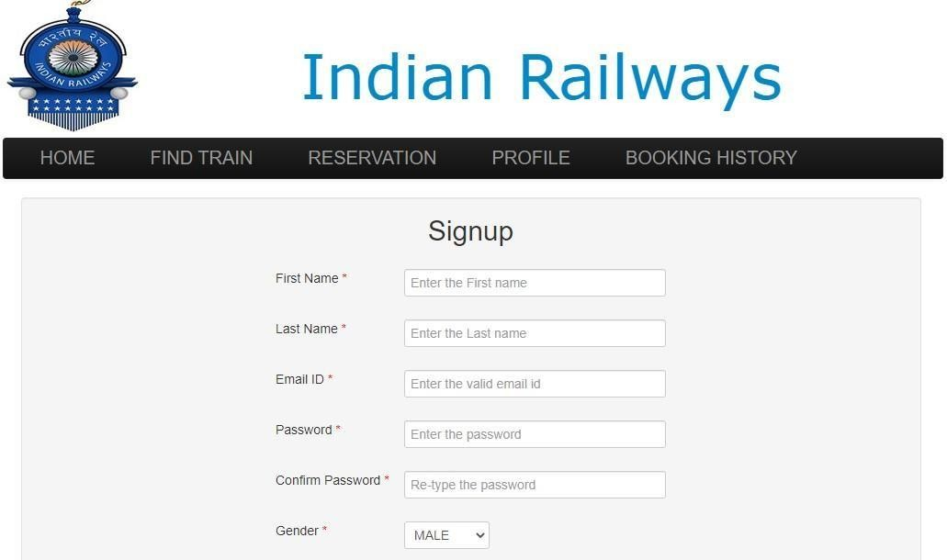

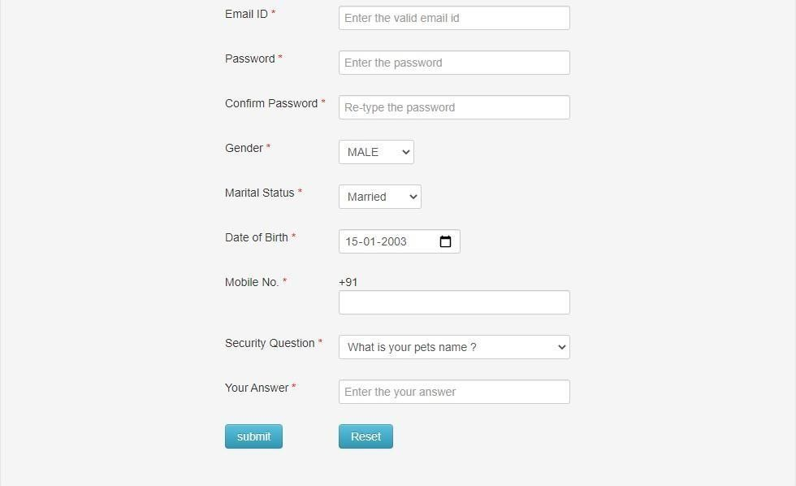

FIG 6.2 SIGN UP PAGE

ADMIN LOGIN PAGE
This page allows admin to login and make changes to data base as shown in Fig B.3

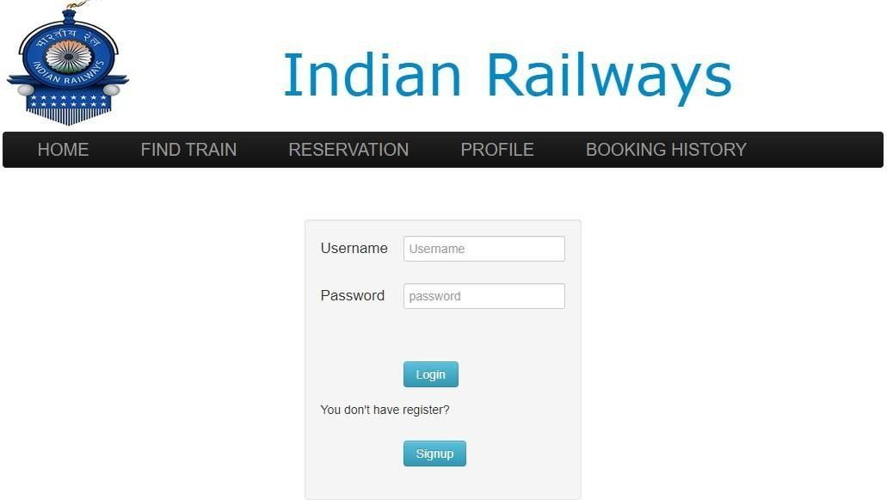

FIG 6.3 ADMIN LOGIN PAGE

ADMIN FIND TRAIN PAGE
This page allows admin to find the train as shown in the FigB.4

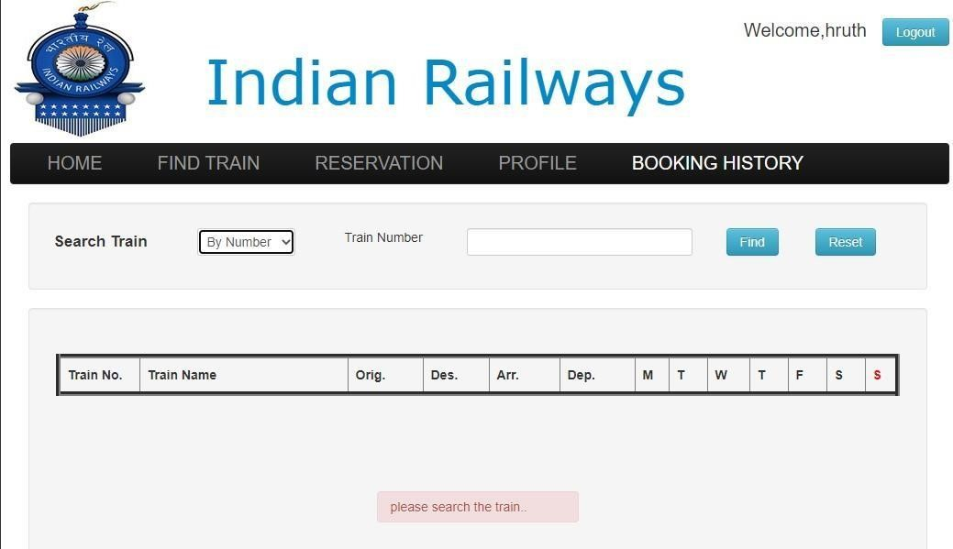

FIG 6.4 ADMIN FIND TRAIN PAGE

ADMIN BOOKING RESERVATION PAGE
This page allows admin to book the tickets as show in the Fig B.5
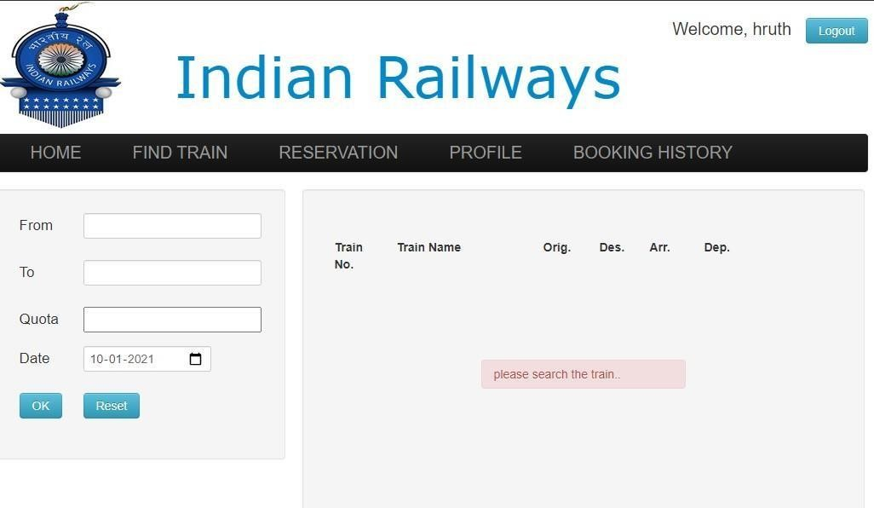

FIG 6.5 ADMIN BOOKING RESERVATION PAGE

ADMIN BOOKING HISTORY
This page allows admin to see the Booking history as shown in the fig B.6

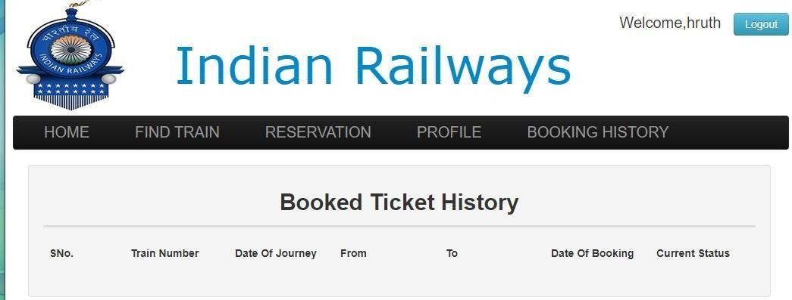

FIG 6.6 ADMIN BOOKING HISTORY

CHAPTER 7

CONCLUSION AND FUTURE ENHANCEMENTS

CONCLUSION

The RAILWAY MANAGEMENT SYSTEM is a great improvement over the manual system which is unreliable and inefficient. The computerization of the system speeds up the process. This system was thoroughly checked and tested with dummy data and found to be reliable.

MERITS

- The RAILWAY MANAGEMENT SYSTEM is fast, efficient and reliable.

- Avoids data redundancy and inconsistency

- Any number of users can use it simultaneously

- Provides more security and integrity to data

FUTURE ENHANCEMENTS

As the technology emerges, it is possible to upgrade the system and can be adaptable to desired environment. Based on the future security issues, security can be improved using emerging technologies. Sub admin module can also be added. It can also be evolved to accept various other types of data including biometric data such as retina data and DNA data.

BIBLIOGRAPHY

WEB SITES REFERENCES:

    - https://github.com/

    - http://php.net/

    - https://www.http://en.wikipedia.org/wiki/PHP

    - https://www.w3shools.com

PERSONAL DETAILS

Name: PAVAN MADIVAL USN: 1DT20CS094
SEM: 5TH SEM ‘B’ SEC
COLLEGE: DAYANADA SAGAR ACADEMY OF TECHNOLOGY AND MANAGEMENT
EMAIL-ID: madivalpavan352@gmail.com

Name: RAJESH KUMAR USN: 1DT20CS106 SEM: 5TH SEM ‘B’ SEC
COLLEGE: DAYANADA SAGAR ACADEMY OF TECHNOLOGY AND MANAGEMENT
EMAIL-ID: rajeshaman218@gmail.com

Name: SAHIL SHARMA USN: 1DT20CS116 SEM: 5TH SEM ‘B’ SEC
COLLEGE: DAYANADA SAGAR ACADEMY OF TECHNOLOGY AND MANAGEMENT
EMAIL-ID: sahilsharma7206@gmail.com

